- INTRODUCTION

Brushless DC motors have been used in various industrial and domestic applications. Due to overweighing merits of this motor, there is continuing trend to propose improved control schemes to enhance the performance of the motor. For analysis of the BLDC motor drives system under various conditions, models such as d-q model and abc phase variable models have been developed. Several simulation models were proposed based on non-linear state-space equations.
BLDC Motor considered in these models is star connected with neutral grounding, but several applications require isolated neutral. Keeping merits of these developments in view, in this paper the motor is modeled as star connected with isolated neutral and the voltages supplied are line-line. Modeling the complete control scheme is beneficial in carrying out the comprehensive simulation studies. Such comprehensive simulation studies are not reported. This paper deals with simulation models of PWM inverter and the controllers for the BLDC motor. The performance of this simulation is examined under no-load, variable load at variable speeds, blocked rotor and intermittent loads. In addition, four quadrant operation of BLDC motor is also carried out.

2. LITERATURE SURVEY

G.R.Puttalakshmi , and S.Paramasivam Proc of 2nd International Conference on Advances in Electrical and Electronics Engineering (ICAEEE'2013) Dec. 20-21, 2013 Bali (Indonesia). The paper presents Two Refernce Based Controller For Bldc Motorin Electric Power Assisted Steering.This work proposes a novel electrical system in steering control using a PID controller. This method eliminates a noise and more accurate than in its mechanical counter parts.

Hemchand Immaneni from GITAM UNIVERSITY, VISAKHAPATNAM, INDIA. In Hemchand Immaneni / International Journal of Engineering Research and Applications
(IJERA) ISSN: 2248-9622 www.ijera.com Vol. 3, Issue 3, May-Jun 2013, pp.1050-
1057.This paper gives a Mathematical Modelling And Position Control Of Brushless Dc (Bldc) Motor. he aim of the paper is to design a simulation model of Permanent Magnet Brushless DC (PMBLDC) motor and to control its position. In the developed model, the characteristics of the speed, torque, back EMF, voltages as well as currents are effectively monitored and analysed.

Vinod KR Singh Patel and A.K.Pandey from * DEPARTMENT OF ELECTRICAL ENGINEERING, M.M.M. ENGINEERING COLLEGE, GORAKHPUR (U.P.), RESEARCH SCHOLAR(ELECTRICAL ENGINEERING, M.M.M.ENGINEERING COLLEGE)**ASSOCIATE PROF(ELECTRONICS ENGINEERING, M.M.M.ENGINEERING COLLEGE) on International Journal of Scientific and Research Publications, Volume 3, Issue 4, April 2013 ISSN 2250-3153.This paper describes Modeling and Performance Analysis of PID Controlled BLDC Motor and Different Schemes of PWM Controlled BLDC Motor.The aim of this paper Brushless dc (BLDC) motor drives are continually gaining popularity in motion control applications. Therefore, it is necessary to have a low cost, but effective BLDC motor speed/torque regulator.

Purna Chandra Rao, Y. P. Obuleshand Ch. Sai Babu from EEE Department, PVPSIT, Vijayawada, Andhra Pradesh, India EEE Department, LBRCE, Maylavaram, India EEE Department, JNTUK, Kakinada, Andhra Pradesh, India on VOL. 7, NO. 10, OCTOBER 2012 ISSN 1819-6608 ARPN Journal of Engineering and Applied Sciences.This paper describs on MATHEMATICAL MODELING OF BLDC MOTOR WITH CLOSED LOOP SPEED CONTROL USING PID CONTROLLER UNDER VARIOUS LOADING CONDITIONS.The aim of project is In the recent past, variable speed driving systems have sprouted in various small scale and large scale applications like automobile industries, domestic appliances etc. The usage of green and eco friendly electronics are greatly developed to save the energy consumption of various devices. This lead to the development in Brushless DC motor (BLDCM). The usage of BLDCM enhances various performance factors ranging from higher efficiency, higher torque in low-speed range, high power density, low maintenance and less noise than other motors.

Neyram Hemati, Member, IEEE, and Ming C. Leu, Member, IEEE on IEEE TRANSACTIONS ON INDUSTRY APPLICATIONS, VOL. 28, NO.JANUARY/FEBRUARY 199 of the topic A Complete Model Characterization of Brushless dc Motors. his paperaddresses the modeling problem associ- ated with brushless dc motors (BLDCM’s) with nonuniform air gaps that operate in a range where magnetic saturation may exist. The mathematical model includes the effects of reluctance variations as well as magnetic saturation to guarantee proper modeling of the system. An experimental procedure is developed and implemented in a laboratory environment to identify the electromagnetic characteristics of a BLDCM in the presence of magnetic saturation.

- BRUSHLESS DC (BLDC)

  - INTRODUCTION OF BLDC

Brushless Direct Current (BLDC) motors are one of the motor types rapidly gaining popularity. BLDC motors are used in industries such as Appliances, Automotive, Aerospace, Consumer, Medical, Industrial Automation Equipment and Instrumentation. As the name implies, BLDC motors do not use brushes for commutation; instead, they are electronically commutated. BLDC motors have many advantages over brushed DC motors and induction motors. A few of these are:

• Better speed versus torque characteristics
• High dynamic response
• High efficiency
• Long operating life
• Noiseless operation
• Higher speed ranges

In addition, the ratio of torque delivered to the size of the motor is higher, making it useful in applications where space and weight are critical factors. In this application note, we will discuss in detail the construction, working principle, characteristics and typical applications of BLDC motors..

3.2 CONSTRUCTION AND OPERATING PRINCIPLE

BLDC motors are a type of synchronous motor. This means the magnetic field generated by the stator and the magnetic field generated by the rotor rotates at the same frequency. BLDC motors do not experience the “slip” that is normally seen in induction motors.

BLDC motors come in single-phase, 2-phase and 3-phase configurations. Corresponding to its type, the stator has the same number of windings. Out of these, 3-phase motors are the most popular and widely used. This application note focuses on 3-phase motors.

3.2.1 STATOR
The stator of a BLDC motor consists of stacked steel laminations with windings placed in the slots that are axially cut along the inner periphery (as shown in Figure 3.3). Traditionally, the stator resembles that of an induction motor; however, the windings are distributed in a different manner. Most BLDC motors have three stator windings connected in star fashion. Each of these windings are constructed with numerous coils interconnected to form a winding. One or more coils are placed in the slots and they are interconnected to make a winding. Each of these windings are distributed over the stator periphery to form an even numbers of poles. There are two types of stator windings variants: trapezoidal and sinusoidal motors.
This differentiation is made on the basis of the interconnection of coils in the stator windings to give the different types of back Electromotive Force (EMF). Refer to the “What is Back EMF?” section for more information.

As their names indicate, the trapezoidal motor gives a back EMF in trapezoidal fashion and the sinusoidal motor’s back EMF is sinusoidal, as shown in Figure 3.1 and Figure 3.2. In addition to the back EMF, the phase current also has trapezoidal and sinusoidal variations in the respective types of motor. This makes the torque output by a sinusoidal motor smoother than that of a trapezoidal motor. However, this comes with an extra cost, as the sinusoidal motors take extra winding interconnections because of the coils distribution on the stator periphery, thereby increasing the copper intake by the stator windings.

Depending upon the control power supply capability, the motor with the correct voltage rating of the stator can be chosen. Forty-eight volts, or less voltage rated motors are used in automotive, robotics, small arm movements and soon. Motors with 100 volts, or higher ratings, are used in appliances, automation and in industrial applications.

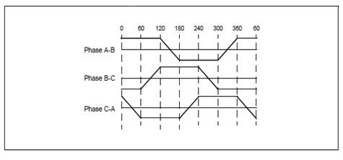
Fig 3.1 Trapezoidal Back Emf

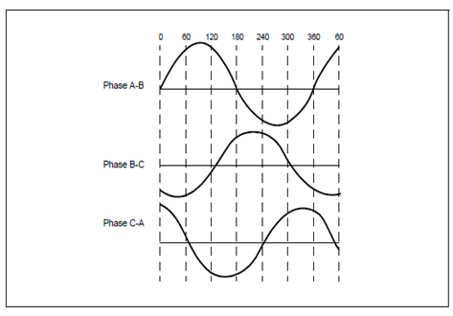
Fig 3.2 Sinusoidal Back Emf

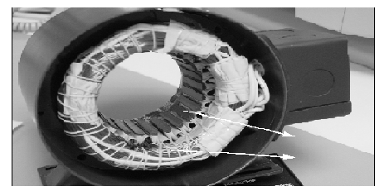
Fig 3.3 Stator Of Bldc Motor

3.2.2 ROTOR

The rotor is made of permanent magnet and can vary from two to eight pole pairs with alternate North (N) and South (S) poles. Based on the required magnetic field density in the rotor, the proper magnetic material is chosen to make the rotor. Ferrite magnets are traditionally used to make permanent magnets. As the technology advances, rare earth alloy magnets are gaining popularity. The ferrite magnets are less expensive but they have the disadvantage of low flux density for a given volume. In contrast, the alloy material has high magnetic density per volume and enables the rotor to compress further for the same torque.

Also, these alloy magnets improve the size-to-weight ratio and give higher torque for the same size motor using ferrite magnets. Neodymium (Nd), Samarium Cobalt (SmCo) and the alloy of Neodymium, Ferrite and Boron (NdFeB) are some examples of rare earth alloy magnets. Continuous research is going on to improve the flux density to compress the rotor further.
Figure 4 shows cross sections of different arrangements of magnets in a rotor.

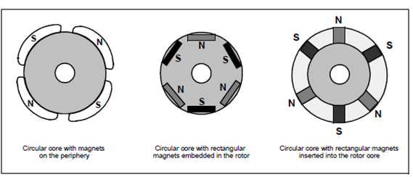
Fig 3.4 rotor magnet cross sections

3.3 HALL SENSORS

Unlike a brushed DC motor, the commutation of a BLDC motor is controlled electronically. To rotate the BLDC motor, the stator windings should be energized in a sequence. It is important to know the rotor position in order to understand which winding will be energized following the energizing sequence. Rotor position is sensed using Hall effect sensors embedded into the stator.

Most BLDC motors have three Hall sensors embedded into the stator on the non-driving end of the motor. Whenever the rotor magnetic poles pass near the Hall sensors, they give a high or low signal, indicating the N or S pole is passing near the sensors. Based on the combination of these three Hall sensor signals, the exact sequence of commutation can be determined.

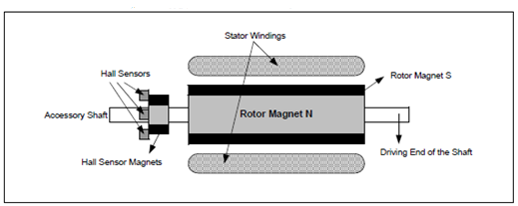
Fig 3.5 Bldc motor transverse section

Figure 3.5 shows a transverse section of a BLDC motor with a rotor that has alternate N and S permanent magnets. Hall sensors are embedded into the stationary part of the motor. Embedding the Hall sensors into the stator is a complex process because any misalignment in these Hall sensors, with respect to the rotor magnets, will generate an error in determination of the rotor position.

To simplify the process of mounting the Hall sensors onto the stator, some motors may have the Hall sensor magnets on the rotor, in addition to the main rotor magnets. These are a scaled down replica version of the rotor. Therefore, whenever the rotor rotates, the Hall sensor magnets give the same effect as the main magnets. The Hall sensors are normally mounted on a PC board and fixed to the enclosure cap on the non-driving end. This enables users to adjust the complete assembly of Hall sensors, to align with the rotor magnets, in order to achieve the best performance.
Based on the physical position of the Hall sensors, there are two versions of output. The Hall sensors may be at 60° or 120° phase shift to each other. Based on this, the motor manufacturer defines the commutation sequence, which should be followed when controlling the motor.

3.4 Theory of Operation

Each commutation sequence has one of the windings energized to positive power (current enters into the winding), the second winding is negative (current exits the winding) and the third is in a non-energized condition. Torque is produced because of the interaction between the magnetic field generated by the stator coils and the permanent magnets. Ideally, the peak torque occurs when these two fields are at 90° to each other and falls off as the fields move together. In order to keep the motor running, the magnetic field produced by the windings should shift position, as the rotor moves to catch up with the stator field. What is known as “Six-Step Commutation” defines the sequence of energizing the windings. See the “Commutation Sequence” section for detailed information and an example on six-step commutation.

3.5 Torque/Speed Characteristics

Figure 6 shows an example of torque/speed characteristics. There are two torque parameters used to define a BLDC motor, peak torque (TP) and rated torque (TR). During continuous operations, the motor can be loaded up to the rated torque. As discussed earlier, in a BLDC motor, the torque remains constant for a speed range up to the rated speed. The motor can be run up to the maximum speed, which can be up to 150% of the rated speed, but the torque starts dropping.
Applications that have frequent starts and stops and frequent reversals of rotation with load on the motor, demand more torque than the rated torque. This requirement comes for a brief period, especially when the motor starts from a standstill and during acceleration. During this period, extra torque is required to overcome the inertia of the load and the rotor itself. The motor can deliver a higher torque, maximum up to peak torque, as long as it follows the speed torque curve. Refer to the “Selecting a Suitable Motor Rating for the Application” section to understand how to select these parameters for an application.
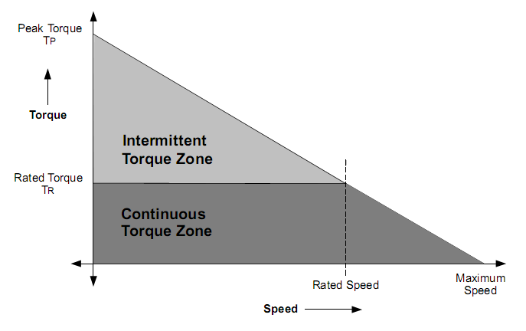Fig 3.6 Torque/Speed Characteristics

3.6 Sensor less Control of BLDC Motors
Until now we have seen commutation based on the rotor position given by the Hall sensor. BLDC motors can be commutated by monitoring the back EMF signals instead of the Hall sensors. The relationship between the Hall sensors and back EMF, with respect to the phase voltage, is shown in Figure 3.7. As we have seen in earlier sections, every commutation sequence has one of the windings energized positive, the second negative and the third left open. As shown in Figure 3.7, the Hall sensor signal changes the state when the voltage polarity of back EMF crosses from a positive to negative or from negative to positive. In ideal cases, this happens on zero-crossing of back EMF, but practically, there will be a delay due to the winding characteristics. This delay should be compensated by the microcontroller.
Another aspect to be considered is very low speeds. Because back EMF is proportional to the speed of rotation, at a very low speed, the back EMF would be at a very low amplitude to detect zero-crossing. The motor has to be started in open loop, from standstill and when sufficient back EMF is built to detect the zero-cross point, the control should be shifted to the back EMF sensing. The minimum speed at which back EMF can be sensed is calculated from the back EMF constant of the motor.
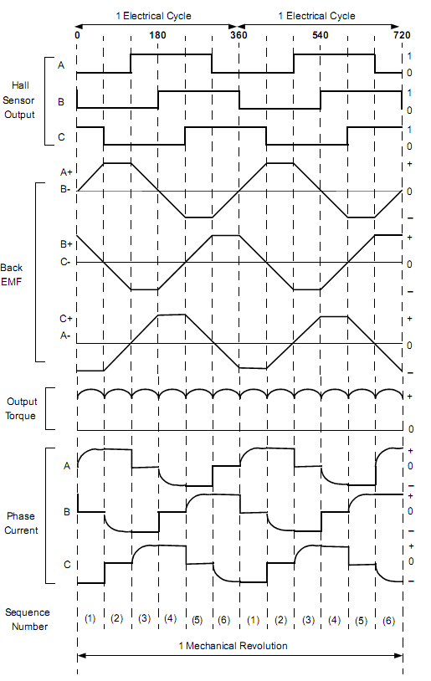
Fig 3.7 Hall Sensor Signal, Back Emf, Output Torque And Phase Current

With this method of commutation, the Hall sensors can be eliminated and in some motors, the magnets for Hall sensors also can be eliminated. This simplifies the motor construction and reduces the cost as well. This is advantageous if the motor is operating in dusty or oily environments, where occasional cleaning is required in order for the Hall sensors to sense properly. The same thing applies if the motor is mounted in a less accessible location.

3.7 TYPICAL BLDC MOTOR APPLICATIONS:

BLDC motors find applications in every segment of the market. Automotive, appliance, industrial controls, automation, aviation and so on, have applications for BLDC motors. Out of these, we can categorize the type of BLDC motor control into three major types:

• Constant load
• Varying loads
• Positioning applications

Applications with Constant Loads
These are the types of applications where a variable speed is more important than keeping the accuracy of the speed at a set speed. In addition, the acceleration and deceleration rates are not dynamically changing. In these types of applications, the load is directly coupled to the motor shaft. For example, fans, pumps and blowers come under these types of applications. These applications demand low-cost controllers, mostly operating in open-loop.

Applications with Varying Loads
These are the types of applications where the load on the motor varies over a speed range. These applications may demand high-speed control accuracy and good dynamic responses. In home appliances, washers, dryers and compressors are good examples. In automotive, fuel pump control, electronic steering control, engine control and electric vehicle control are good examples of these. In aerospace, there are a number of applications, like centrifuges, pumps, robotic arm controls, gyroscope controls and so on.

These applications may use speed feedback devices and may run in semi-closed loop or in total closed loop. These applications use advanced control algorithms, thus complicating the controller. Also, this increases the price of the complete system.

Positioning Applications

Most of the industrial and automation types of application come under this category. The applications in this category have some kind of power transmission, which could be mechanical gears or timer belts, or a simple belt driven system. In these applications, the dynamic response of speed and torque are important. Also, these applications may have frequent reversal of rotation direction.
A typical cycle will have an accelerating phase, a constant speed phase and a deceleration and positioning phase, as shown in Figure 3.8. The load on the motor may vary during all of these phases, causing the controller to be complex. These systems mostly operate in closed loop. There could be three control loops functioning simultaneously: Torque Control Loop, Speed Control Loop and Position Control Loop. Optical encoder or synchronous resolvers are used for measuring the actual speed of the motor.
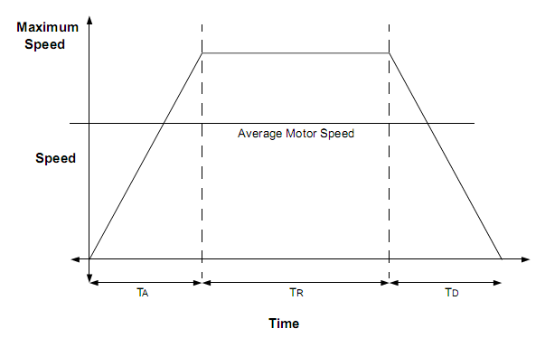
Fig 3.8 Trapezoidal Speed Curve
In some cases, the same sensors are used to get relative position information. Otherwise, separate position sensors may be used to get absolute positions. Computer Numeric Controlled (CNC) machines are a good example of this. Process controls, machinery controls and conveyer controls have plenty of applications in this category.

3.8 UNIPOLAR EXCITATION OF BLDC MOTORS

The motor under investigation is of the surface-mount permanent magnet variety with concentrated stator windings such that the induced back-EMFs with respect to rotor position are trapezoidal with a flat-top width that is as wide as possible. Smooth torque production requires forcing a constant current through each phase winding when its back-EMF is at its peak value and turning off the current when the back-EMF is changing.

For bipolar excitation, positive current is injected when the back-EMF is positive and negative current when the back-EMF is negative, with each conduction period lasting 120. This results in two phases conducting current and producing torque at any instant of time. Unipolar current conduction limits the phases to only one direction of current . Constant torque production is still possible because one phase is conducting current at any instant. It is of course possible to have an overlap in the phase conduction to have a smoother torque production. In any case, the motor windings are poorly utilized compared to the bipolar case.

This is reflected in the lower output torque of the unipolar motor for the same peak phase currents. The primary motivation for choosing unipolar excitation is that in practice, the inverter typically costs more than the motor and there is a great potential for reducing its cost and hence the overall cost of the drive. In addition to cost reduction, unipolar excitation offers the following advantages:
- There is only one device in series with each phase, minimizing conduction losses.
- The risk of shoot-through faults is eliminated.
- Switching of devices connected to the supply rails, which generally requires some isolation circuitry, can be avoided.

Another factor that has to be considered before choosing unipolar excitation is that the motor neutral has to be available because the phase currents are no longer balanced.

Cost minimization is the key to the large volume manufacture and application of brushless dc (BLDC) motors in variable speed drives. BLDC motors are conventionally excited with bipolar currents which requires a six-switch inverter

3.9 TWO-PHASE MOTOR

We first consider a 2-phase motor with 4 slots as shown in Fig 3.9. This is an integral slots/pole motor and the coil span is 2 slots. The currents are used to excite this motor. This drive requires only one position sensor and a single current sensor. The number of turns/phase is higher than the reference for the same amount of copper. This results in higher peak torque, the torque ripple of this motor with unipolar currents is very high. This is because commutation between the phases takes place during the zero crossing of the back-EMF. This can be avoided by increasing the number of phases.

. 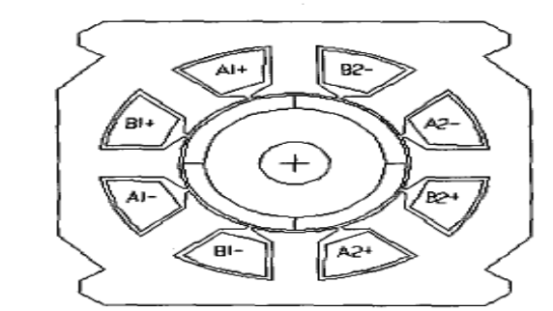
Fig 3.9 2-phase 4-slot BLDC motor

3.10 THREE-PHASE MOTORS
Let us consider a 3-phase, 12-slot motor as shown in Fig 3.10(a).In this case, the commutation takes place before the back-EMF of each phase reaches zero, and the ripple is reduced . When we use the currents in the torque ripple is worse. This is because different numbers of phases contribute to the torque at different instants of time. From the previous two cases, we realize that we need a combination of 180' unipolar currents and small back-EMF width to reduce the torque pulsation.
To investigate this case, we consider the 6-slot motor shown in Fig 3.10(b).
We find that the 6-slot motor has a higher peak and smaller back-EMF width than the 12-slot motor. This can be explained as follows.
The end-turns are shorter for the 6-slot motor, because of which the number of turns per coil is more for the same amount of copper. This increases the peak value of the back emf. The maximum coil span or winding pitch is determined by dividing the number of slots by the number of poles and rounding off to the next lowest integer . For the 12-slot motor, the slots/pole is 3, and th-, coils are full-pitched, which maximizes the width of the back-emf. In the 6-slot motor, the slots/pole is 1.5, and the coil span used is 1 because of which the width of the back-EMF waveform is smaller.

This effect can also be achieved by short-pitching the coils in an integral slots/pole design. The possible short-pitch coil spans for the 12-slot motor are 1 and 2. Using a coil span of 1 would make the back-EMF width too narrow and increase the torque ripple. A coil span of 2 would be ideal, but would leave half the slots unutilized. Using a fractional slots/pole motor has the additional advantage of reducing the cogging torque. If the number of slots is increased to 24 or 32, many more combinations are possible for obtaining smaller back-EMF width, and the designer can then make a choice based on other considerations.

However, in general, the smallest number of slots gives the lowest labor cost in winding, and a coil span of 1 or 2 slots minimizes the end turns. Note that similar results could also be obtained by using full-pitch stator coils and a magnet pole arc of 120' electrical as discussed.

We see that the 3-ph 6-slot motor excited with 180' unipolar currents gives better performance in terms of torque ripple, with some loss in peak and average torque. This is explained as follows. We have one phase conducting during intervals 2,4 and 6 and two phases conducting during intervals 1,3 and 5. In particular, when the back-emf of phase A reaches its peak during interval 2, only phase A is conducting.

When the back-emf of phase A starts decreasing in interval 3, phase B also comes into conduction. The decreasing torque contribution of phase A is compensated by the increasing contribution from phase B. The result is an almost constant torque over the entire cycle. The remaining case of the 6-slot motor excited with 126 unipolar currents results in high torque ripple because the back-emf during the commutation instants is low.

Both the unipolar and the bipolar drives require three hall-effect sensors, with the second and third displaced by 120" and 240" electrical respectively from the first. The bipolar drive requires six switches while the unipolar drive requires only three, albeit with higher current ratings. The advantage of using 120" currents is that we require only one current sensor in the dc link. However, the torque ripple is not low enough. It can be reduced further by increasing the
number of phases to four.

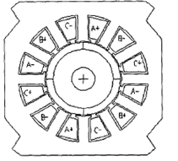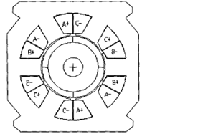
Fig 3.10(a) 3-Ø 12-slot BLDC motor Fig 3.10(b) 3-Ø 6-slot BLDC motor

Motor Description | Turns/phase | Current waveform | Max. torque  (N-m) | Avg.torue  (N-m) | Torque ripple
3-ph 12 slot | 208 | 120⁰ Bipolar | 0.4943 | 0.4632 | 13%
3-ph 12 slot | 208 | 120⁰ Unipolar | 0.3662 | 0.3272 | 23.7%
3-ph 12 slot | 208 | 180⁰ Unipolar | 0.4972 | 0.3525 | 73.6%
3-ph 6 slot | 262 | 120⁰ Unipolar | 0.4065 | 0.3726 | 70%
3-ph 6 slot | 262 | 180⁰ Unipolar | 0.3383 | 0.3247 | 8.53%

Table 2: COMPERISION OF 3-PHASE MOTORS WITH THE REFERENCE

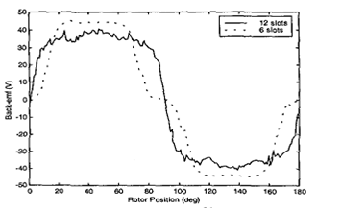
Fig 3.11 Back emf plots of 3-phase motors

3.11 FOUR-PHASE MOTORS

Two 4-phase motors are considered: One with I6 slots, and the other with 8 slots as shown in Fig 3.12(a) and Fig 3.12(b). Both motors are integral slots/pole designs. The 16-slot motor is short-pitched by a factor of 2, while the 8 slot motor is full-pitched, which

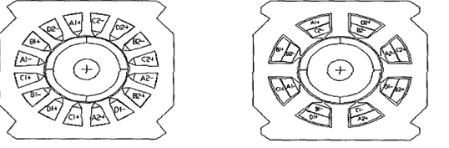

Fig 3.12(a) 4-phase 16- slot BLDC motor Fig 3.12 (b) 4-phase 16- slot BLDC motor
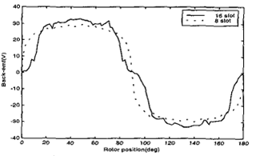
Fig 3.13 Back emf plots of 4-phase motors

Explains the difference in the width of their back-emf waveforms shown in Fig 1.13. The number of turns/phase is more in the 16-slot motor because of the shorter end-turns, which explains the higher peak of its back-emf. For both motors, using 90' conduction gives better results because the commutation between phases takes place when the back-emfs are high.
In addition, it requires the use of only a single current sensor in the dc link. In the 180" conduction scheme, two phases conduct at all times, and the back-emfs of the incoming and outgoing phases are low, resulting in large torque ripple. It also requires the use of a current sensor in each phase.
3.12 Four-Quadrant Operation
Firstly, the steady-state speed is determined by the applied voltage, so we can make the motor run at any desired speed in either direction simply by applying the appropriate magnitude and polarity of the armature voltage. Secondly, the torque is directly proportional to the armature current, which in turn depends on the difference between the applied voltage V and the back e.m.f. E. We can therefore make the machine develop positive (motoring) or negative (generating) torque simply by controlling the extent to which the applied voltage is greater or less than the back e.m.f. An armature voltage controlled d.c. machine is therefore inherently capable of what is known as four-quadrant operation, with reference to the numbered quadrants of the torque-speed plane shown in Figure 3.14.
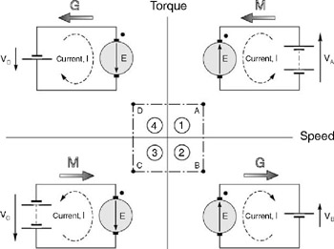
Fig 3.14 Operation of d.c. motor in the four quadrants of the torque-speed plane
Figure 3.14 looks straightforward but experience shows that to draw the diagram correctly calls for a clear head, so it is worth spelling out the key points in detail. A proper understanding of this diagram is invaluable as an aid to seeing how controlled-speed drives operate.
Firstly, one of the motor terminals is shown with a dot, and in all four quadrants the dot is uppermost. The purpose of this convention is to indicate the sign of the torque: if current flows into the dot, the machine produces positive torque, and if current lows out of the dot, the torque is negative. Secondly, the supply voltage is shown by the old-fashioned battery symbol, as use of the more modern circle symbol for a voltage source would make it more difficult to differentiate between the source and the circle representing the machine armature. The relative magnitudes of applied voltage and motional e.m.f. are emphasised by the use of two battery cells when V > E and one when V < E.
We have seen that in a d.c. machine speed is determined by applied voltage and torque is determined by current. Hence on the right-hand side of the diagram the supply voltage is positive (upwards), while on the left-hand side the supply voltage is negative (downwards). And in the upper half of the diagram current is positive (into the dot), while in the lower half it is negative (out of the dot). For the sake of convenience, each of the four operating conditions (A, B, C, D) have the same magnitude of speed and the same magnitude of torque: these translate to equal magnitudes of motional e.m.f. and current for each condition. When the machine is operating as a motor and running in the forward direction, it is operating in quadrant 1.
The applied voltage VA is positive and greater than the back e.m.f. E, and positive current therefore flows into the motor: in Figure 3.14, the arrow representing VA has accordingly been drawn larger than E. The power drawn from the supply (VAI) is positive in this quadrant, as shown by the shaded arrow labelled M to represent motoring. The power converted to mechanical form is given by EI, and an amount I2R is lost as heat in the armature. If E is much greater than IR (which is true in all but small motors), most of the input power is converted to mechanical power, i.e. the conversion process is efficient. If, with the motor running at position A, we suddenly reduce the supply voltage to a value VB which is less than the back e.m.f., the current (and hence torque) will reverse direction, shifting the operating point to B in Figure 3.14. There can be no sudden change in speed, so the e.m.f. will remain the same. If the new voltage is chosen so that E — VB = VA — E, the new current will have the same amplitude as at position A, so the new (negative) torque will be the same as the original positive torque.
But now power is supplied from the machine to the supply, i.e. the machine is acting as a generator, as shown by the shaded arrow.
We should be quite clear that all that was necessary to accomplish this remarkable reversal of power flow was a modest reduction of the voltage applied to the machine. At position A, the applied voltage was E + IR, while at position B it is E-IR. Since IR will be small compared with E, the change (2IR) is also small. Needless to say the motor will not remain at point B if left to its own devices. The combined effect of the load torque and the negative machine torque will cause the speed to fall, so that the back e.m.f. again falls below the applied voltage VB, the current and torque become positive again, and the motor settles back into quadrant 1, at a lower speed corresponding to the new (lower) supply voltage. During the deceleration phase, kinetic energy from the motor and load inertias is returned to the supply.
This is therefore an example of regenerative braking, and it occurs naturally every time we reduce the voltage in order to lower the speed. If we want to operate continuously at position B, the machine will have to be driven by a mechanical source. We have seen above that the natural tendency of the machine is to run at a lower speed than that corresponding to point B, so we must force it to run faster, and create an e.m.f greater than VB, if we wish it to generate continuously.
It should be obvious that similar arguments to those set out above apply when the motor is running in reverse (i.e. V is negative). Motoring then takes place in quadrant 3 (point C), with brief excursions into quadrant 4 (point D, accompanied by regenerative braking), whenever the voltage is reduced in order to lower the speed.

- INVERETER

4.1 INTRODUCTION TO INVERTERS

The main objective of static power converters is to produce an ac output waveform from a dc power supply. These are the types of waveforms required in adjustable speed drives (ASDs), uninterruptible power supplies (UPS), static VAR compensators, active filters, flexible ac transmission systems (FACTS), and voltage compensators, which are only a few applications. For sinusoidal ac outputs, the magnitude, frequency, and phase should be controllable. According to the type of ac output waveform, these topologies can be considered as voltage source inverters (VSIs), where the independently controlled ac output is a voltage waveform.

These structures are the most widely used because they naturally behave as voltage sources as required by many industrial applications, such as adjustable speed drives(ASDs), which are the most popular application of inverters; see Fig. 3.1 Similarly, these topologies can be found as current source inverters (CSIs), where the independently controlled ac output is a current waveform. These structures are still widely used in medium-voltage industrial applications, where high-quality voltage waveforms are required.

Static power converters, specifically inverters, are constructed from power switches and the ac output waveforms are therefore made up of discrete values. This leads to the generation of waveforms that feature fast transitions rather than smooth ones. For instance, the ac output voltage produced by the VSI of a standard ASD is a three-level
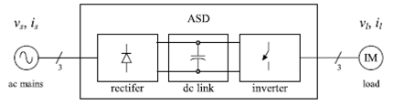
Fig 4.1 Basic designs

4.2 TYPES OF INVERTERS:
Generally inverters are of Two Types:
1. Voltage Source Inverter
2. Current Source Inverter
4.2.1 Single-phase voltage source inverters:

Single-phase voltage source inverters (VSIs) can be found as half-bridge and full-bridge topologies. Although the power range they cover is the low one, they are widely used in power supplies, single-phase UPSs, and currently to form elaborate high-power static power topologies, such as for instance, the multi cell configurations that are reviewed. The main features of both approaches are reviewed and presented in the following.

4.2.2 Types of VSI
4.2.2.1 Half-Bridge VSI:

The power topology of a half-bridge VSI, where two large capacitors are required to provide a neutral point N, such that each capacitor maintains a constant voltage=2. Because the current harmonics injected by the operation of the inverter are low-order harmonics, a set of large capacitors (C. and Cÿ) is required. It is clear that both switches S. and Sÿ cannot be on simultaneously because short circuit across the dc link voltage source vi would be produced. There are two defined (states 1 and 2) and one undefined (state 3) switch state. In order to avoid the short circuit across the dc bus and the undefined ac output voltage condition, the modulating technique should always ensure that at any instant either the top or the bottom switch of the inverter leg is on.
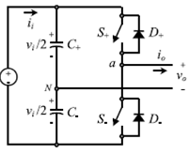
Fig 4.2 single- phase half-bridge VSI

shows the ideal waveforms associated with the half-bridge inverter shown in Fig. 4.2. The states for the switches S. and Sÿ are defined by the modulating technique, which in this case is a carrier-based PWM.
The Carrier-Based Pulse width Modulation (PWM) Technique: As mentioned earlier, it is desired that the ac output voltage. V_{an} follow a given waveform (e.g., sinusoidal) on a continuous basis by properly switching the power valves. The carrier-based PWM technique fulfils such a requirement as it defines the on and off states of the switches of one leg of a VSI by comparing a modulating signal V_{C} (desired ac output voltage) and a triangular waveform V_{D} (carrier signal). In practice, when V_{C} > V_{D} the switch S. is on and the switch is off; similarly, when V_{C} < V_{D} the switch S. is off and the switch S_{Ÿ} is on.
A special case is when the modulating signal V_{C} is a sinusoidal at frequency fc and amplitude vc , and the triangular signal V_{D} is at frequency fD and amplitude V_{D}. This is the sinusoidal PWM (SPWM) scheme. In this case, the modulation index ma (also known as the amplitude-modulation ratio) is defined as
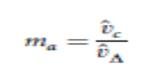
And the normalized carrier frequency mf (also known as the frequency-modulation ratio) is
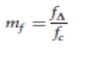
. Van is basically a sinusoidal waveform plus harmonics, which features: (a) the amplitude of the fundamental component of the ac output voltage vo1 satisfying the following expression:
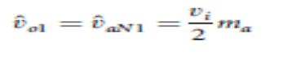

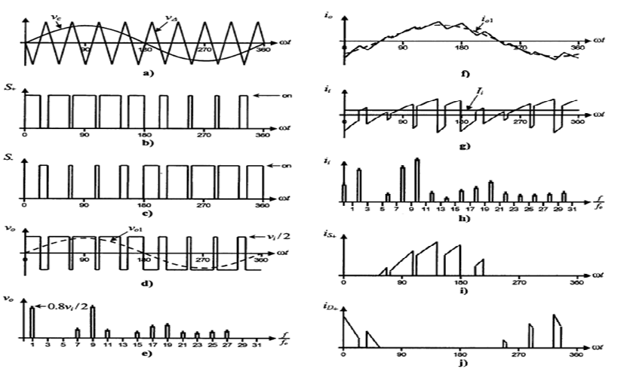
Fig 4.3 Characteristics single- phase half-bridge VSI
will be discussed later); (b) for odd values of the normalized carrier frequency mf the harmonics in the ac output voltage appear at normalized frequencies fh centered around mf and its multiples, specifically,
h=lm_{f} ±k l=1,2,3……..
Where k . 2; 4; 6; . . . for l . 1; 3; 5; . . . ; and k . 1; 3; 5; . . .for l . 2; 4; 6; . . . ; (c) the amplitude of the ac output voltage harmonics is a function of the modulation index ma and is independent of the normalized carrier frequency mf form f > 9; (d) the harmonics in the dc link current (due to the modulation) appear at normalized frequencies fp centered around the normalized carrier frequency mf and its multiples, specifically,
p=lm_{f} ± k ± 1 l=1,2,…….

Where k . 2; 4; 6; . . . for l . 1; 3; 5; . . . ; and k . 1; 3; 5; . .for l . 2; 4; 6; . . . . Additional important issues are: (a) for small values of mf (mf < 21), the carrier signal vD and the modulating signal vc should be synchronized to each other(mf integer), which is required to hold the previous features; if this is not the case, sub harmonics will be present in the ac output voltage; (b) for large values of mf (mf > 21), the sub harmonics are negligible if an asynchronous PWM
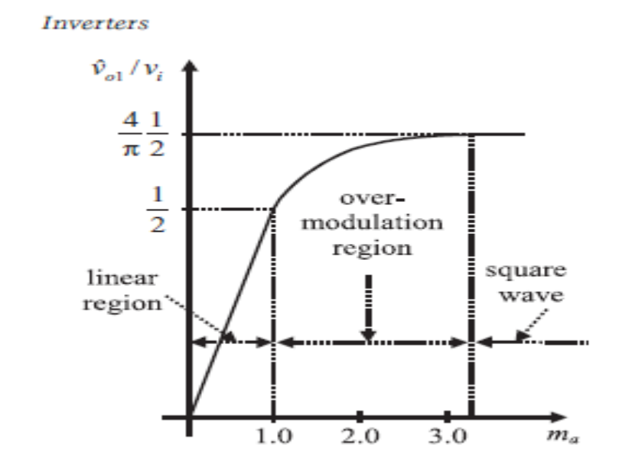
Fig 4.4 PWM technique for Square wave
technique is used, however, due to potential very low-order sub harmonics, its use should be avoided; finally (c) in the over modulation region (ma > 1) some intersections between the carrier and the modulating signal are missed, which leads to the generation of low-order harmonics but a higher fundamental ac output voltage is obtained; unfortunately, the linearity between ma and ^vo1achieved in the linear region does not hold in the over modulation region, moreover, a saturation effect can be observed.
The PWM technique allows an ac output voltage to be generated that tracks a given modulating signal. A special case is the SPWM technique (the modulating signal is a sinusoidal) that provides in the linear region an ac output voltage that varies linearly as a function of the modulation index and the harmonics are at well-defined frequencies and amplitudes.
These features simplify the design of filtering components. Unfortunately, the maximum amplitude of the fundamental ac voltage is vi=2 in this operating mode. Higher voltages are obtained by using the over modulation region (ma > 1); however, low-order harmonics appear in the ac output voltage.
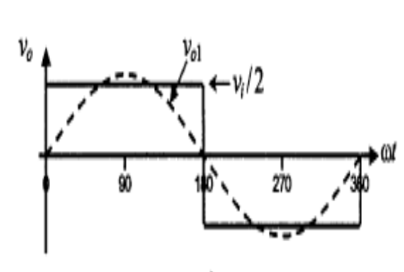
Fig 4.5 Square-Wave Modulating Technique

Both switches S. and Sÿ are on for one-half cycle of the ac output period. This is equivalent to the SPWM technique with an infinite modulation index ma.The normalized ac output voltage harmonics are at frequencies h . 3; 5; 7; 9; . . . , and for a given dc link voltage.

4.2.2.2 Full-Bridge VSI:

The power topology of a full-bridge VSI. This inverter is similar to the half-bridge inverter; however, a second leg provides the neutral point to the load. As expected, both switches S1. and S1ÿ (or S2. and S2ÿ) cannot be on simultaneously because a short circuit across the dc link voltage source vi would be produced.
The undefined condition should be avoided so as to be always capable of defining the ac output voltage. In order to avoid the short circuit across the dc bus and the undefined ac output voltage condition, the modulating technique should ensure that either the top or the bottom switch of each leg is on at any instant. It can be observed that the ac output voltage can take values up to the dc link value vi , which is twice that obtained with half-bridge VSI topologies.
Several modulating techniques have been developed that are applicable to full-bridge VSIs. Among them are the PWM (bipolar and unipolar) techniques.
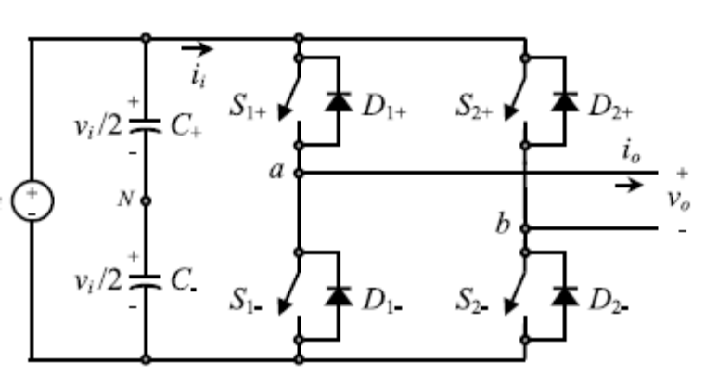
Fig 4.6 Full Bridge VSI

4.2.3 Bipolar PWM Technique

States 1 and 2are used to generate the ac output voltage in this approach. Thus, the ac output voltage waveform features only two values, which are vi and ÿvi. To generate the states, a carrier-based technique can be used a sine half-bridge configurations where only one sinusoidal modulating signal has been used. It should be noted that the on state in switch S. in the half-bridge corresponds to both switches S1. And S2ÿ being in the on state in the full-bridge configuration.
Similarly, Sÿ in the on state in the half-bridge corresponds to both switches S1ÿ andS2. Being in the on state in the full-bridge configuration. This is called bipolar carrier-based SPWM. The ac output voltage waveform in a full-bridge VSI is basically a sinusoidal waveform that features a fundamental component of amplitude ^vo1that satisfies the expression
ύ₀₁= ύ_{ab1}=v_{i}m_{a}
In the linear region of the modulating technique (ma 1), which is twice that obtained in the half-bridge VSI. Identical conclusions can be drawn for the frequencies and amplitudes of the harmonics in the ac output voltage and dc link current, and for operations at smaller and larger values of odd mf(including the over modulation region (ma > 1)), than in half bridge VSIs, but considering that the maximum ac output voltage is the dc link voltage vi .
Thus, in the over modulation region the fundamental component of amplitude ^vo1 satisfies the expression
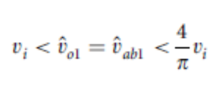
In contrast to the bipolar approach, the unipolar PWM technique uses the states 1, 2, 3, and to generate the ac output voltage. Thus, the ac output voltage waveform can instantaneously take one of three values, namely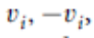The signal vc is used to generate van, and 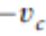is used to generate vbn; 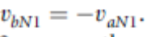.On the other hand, 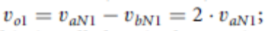thus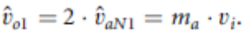 This is called unipolar carrier-based PWM.

Identical conclusions can be drawn for the amplitude of the fundamental component and harmonics in the ac output voltage and dc link current, and for operations at smaller and larger values of mf , (including the over modulation region (ma > 1)), than in full-bridge VSIs modulated by the bipolar SPWM. However, because the phase voltages 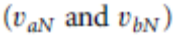are identical but 180_ out of phase, the output voltage 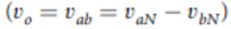will not contain even harmonics. Thus, if mf is taken even, the harmonics in the ac output voltage appear at normalized odd frequencies fh centered around twice the normalized carrier frequency mf and its multiples. Specifically,
h= l_{mf} ± k l=2,4……….
Where k . 1; 3; 5; . . . and the harmonics in the dc link current appear at normalized frequencies fp centered around twice the normalized carrier frequency mf and its multiples. Specifically,
p=l_{mf} ± k±1 l=2,4……….
Where k. 1; 3; 5; . . .. This feature is considered to be an advantage because it allows the use of smaller filtering components to obtain high-quality voltage and current waveforms while using the same switching frequency as in VSIs modulated by the bipolar approach.

4.2.4 Current Source Inverters:

The main objective of these static power converters is tom produce ac output current waveforms from a dc current power supply. For sinusoidal ac outputs, its magnitude, frequency, and phase should be controllable. Due to the fact that the ac line currents ioa, iob, and ioc feature high di=dt, a capacitive filter should be connected at the ac terminals in inductive load applications (such as ASDs).

Thus, nearly sinusoidal load voltages are generated that justifies the use of these topologies in medium-voltage industrial applications, where high-quality voltage waveforms are required.

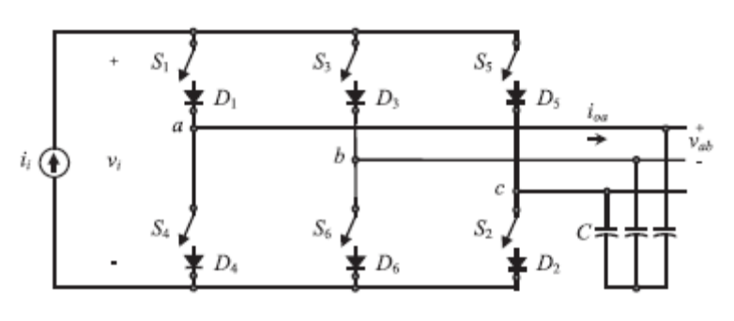
Fig 4.7 Three Phase CSI
Should be closed at any time; the dc bus is of the current-source type and thus it cannot be opened; therefore, there must be at least one top switch and one bottom switch (closed at all times. Note that both constraints can be summarized by stating that at any time, only one top switch and one bottom switch must be closed.
There are nine valid states in three-phase CSIs. produce zero ac line currents. In this case, the dc link current freewheels through either the switches S1 and S4, switches S3 and S6, or switches S5 and S2. The remaining states produce nonzero ac output line currents. In order to generate a given set of ac line current waveforms, the inverter must move from one state to another. Thus, the resulting line currents consist of discrete values of current, which are ii , 0, and ÿii .The selection of the states in order to generate the given waveforms is done by the modulating technique that should ensure the use of only the valid states.

4.3 Carrier-based PWM Techniques in CSIs:

It has been shown that carrier-based PWM techniques that were initially developed for three-phase VSIs can be extended to three-phase CSIs. Obtains the gating pattern for a CSI from the gating pattern developed for a VSI. As a result, the line current appears to be identical to the line voltage in a VSI for similar carrier and modulating signals.

It is composed of a switching pulse generator, a shorting pulse generator, a shorting pulse distributor, and a switching and shorting pulse combinatory. The circuit basically produces the gating signals ..S.1...6 . .S1 . . . S6.T . According to a carrier iD and three modulating signals .ic .abc . .ica icb ica.T .

Therefore, any set of modulating signals which when combined result in a sinusoidal line-to-line set of signals, will satisfy the requirement for a sinusoidal line current pattern. Examples of such a modulating signals are the standard sinusoidal, sinusoidal with third harmonic injection, trapezoidal and dead band waveforms. The first component of this stage (Fig. 14.24) is the switching pulse generator, where the signals .Sa.123 are generated according to:
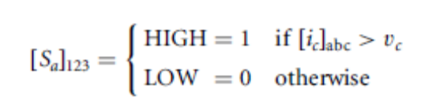
The outputs of the switching pulse generator are the signals .Sc .1...6, which are basically the gating signals of the CSI without the shorting pulses. These are necessary to free wheel the dc link current ii when zero ac output currents are required.The truth table of .Sc .1...6 for all combinations of their inputs .Sa.123. It can be clearly seen that at most one top switch and one bottom switch is on, which satisfies the first constraint of the gating signals as stated before.
In order to satisfy the second constraint, the shorting pulse .Sd . 1. is generated (shorting pulse generator (when none of the top switches .Sc1 . Sc3 . Sc5 . 0. or none of the bottom switches .Sc4 . Sc6 . Sc2 . 0. are gated. Then, this pulse is added (using OR gates) to only one leg of the CSI (either to the switches 1 and 4, 3 and 6, or 5 and 2) by means of the switching and shorting pulse combinatory.

The signals generated by the shorting pulse generator (a) only one leg of the CSI is shorted, as only one of the signals is high at any time; and (b) there is an even distribution of the shorting pulse, as .Se .123 is HIGH for 120 in each period. This ensures that the rms currents are equal in all legs. the relevant waveforms if a triangular carrier iD and sinusoidal modulating signals .ic .abc are used in combination with the gating pattern generator this is SPWM in CSIs.

5. MATLAB
5.1 Introduction to Matlab:
Matlab is a high-performance language for technical computing. The name mat lab stands for matrix laboratory. It integrates computation, visualization, and programming in an easy-to-use environment where problems and solutions are expressed in familiar mathematical notation. Typical uses include Math and computation Algorithm development Data acquisition Modeling, simulation, and prototyping Data analysis, exploration, and visualization Scientific and engineering graphics Application development, including graphical user interface building.

Matlab is an interactive system whose basic data element is an array that does not require dimensioning. This allows you to solve many technical computing problems, especially those with matrix and vector formulations, in a fraction of the time it would take to write a program in a scalar no interactive language such as C or FORTRAN.

5.2 History of Matlab:

Cleve Barry Moler, the chairman of the computer-science department at the University of New Mexico, he is a mathematician and computer programmer specializing in numerical analysis. Started developing MATLAB in the late 1970s. He designed it to give his student’s access to LINPACK and EISPACK without their having to learn FORTRAN. It soon spread to other universities and found a strong audience within the applied mathematics community. Jack Little, an engineer, was exposed to it during a visit Moler made to Stanford University in 1983. Recognizing its commercial potential, he joined with Moler and Steve Bangert. They rewrote MATLAB in C and founded Math Works in 1984 to continue its development. These rewritten libraries were known as JACKPAC. In 2000, MATLAB was rewritten to use a newer set of libraries for matrix manipulation, LAPACK.

5.3 Strengths of Matlab:
- MATLAB is relatively easy to learn.
- MATLAB code is optimized to be relatively quick when performing matrix operations.
- MATLAB may behave like a calculator or as a programming language.
- MATLAB is interpreted, errors are easier to fix.
- Although primarily procedural, MATLAB does have some object-oriented elements.

5.4 Other features:
- 2-D and 3-D graphics functions for visualizing data
- Tools for building custom graphical user interfaces
- Functions for integrating MATLAB based algorithms with external applications and languages, such as C, C++, FORTRAN, Java, COM, and Microsoft Excel.

5.5 Components of Matlab:
- Workspace
- Current Directory
- Command History
- Command Window

5.6 Toolboxes in Matlab:
- Simulink
- Fuzzy
- Genetic algorithm
- Neural network
- Wavelet

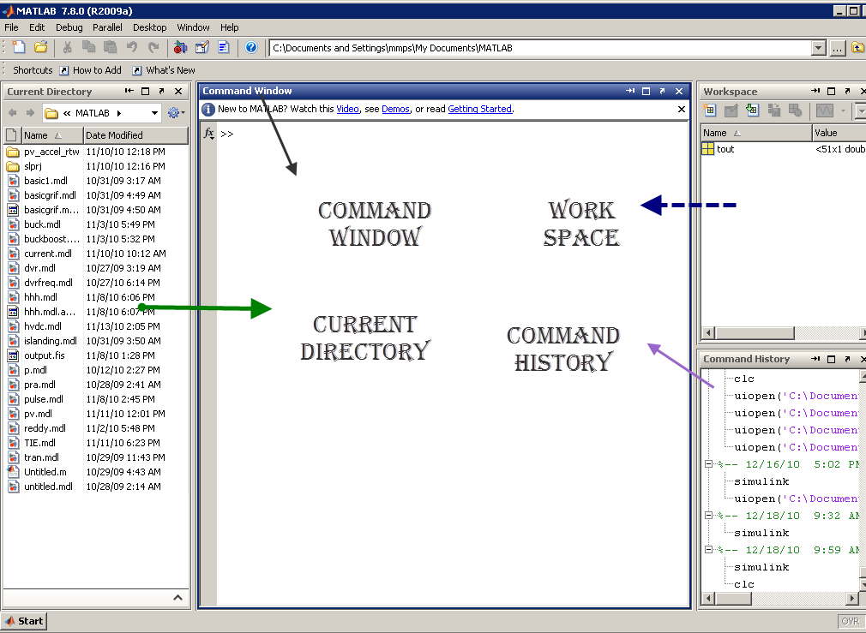
Fig 5.1 Block diagram of Mat lab components

5.7 MATLAB and engineering:
MATLAB was first adopted by researchers and practitioners in control engineering, Little's specialty, but quickly spread to many other domains. It is now also used in education, in particular the teaching of linear algebra and numerical analysis, and is popular amongst scientists involved in image processing. However, many researchers mostly from Computer Science background feel that MATLAB should be used only for mathematical analysis necessary in image processing and not for implementation of image processing software. Moreover, MATLAB should not be used to simulate computer architectures, systems software and computer networks unless while solving some numeric problem.\
  - Simulink:
    - Introduction:
Simulink is a software add-on to mat lab which is a mathematical tool developed by The Math works,(http://www.mathworks.com) a company based in Natick. Mat lab is powered by extensive numerical analysis capability. Simulink is a tool used to visually program a dynamic system (those governed by Differential equations) and look at results. Any logic circuit, or control system for a dynamic system can be built by using standard building blocks available in Simulink Libraries. Various toolboxes for different techniques, such as Fuzzy Logic, Neural Networks, DSP, Statistics etc. are available with Simulink, which enhance the processing power of the tool. The main advantage is the availability of templates / building blocks, which avoid the necessity of typing code for small mathematical processes.

    - Concept of signal and logic flow:
In Simulink, data/information from various blocks are sent to another block by lines connecting the relevant blocks. Signals can be generated and fed into blocks dynamic / static).Data can be fed into functions. Data can then be dumped into sinks, which could be scopes, displays or could be saved to a file. Data can be connected from one block to another, can be branched, multiplexed etc. In simulation, data is processed and transferred only at discrete times, since all computers are discrete systems. Thus, a simulation time step (otherwise called an integration time step) is essential, and the selection of that step is determined by the fastest dynamics in the simulated system.

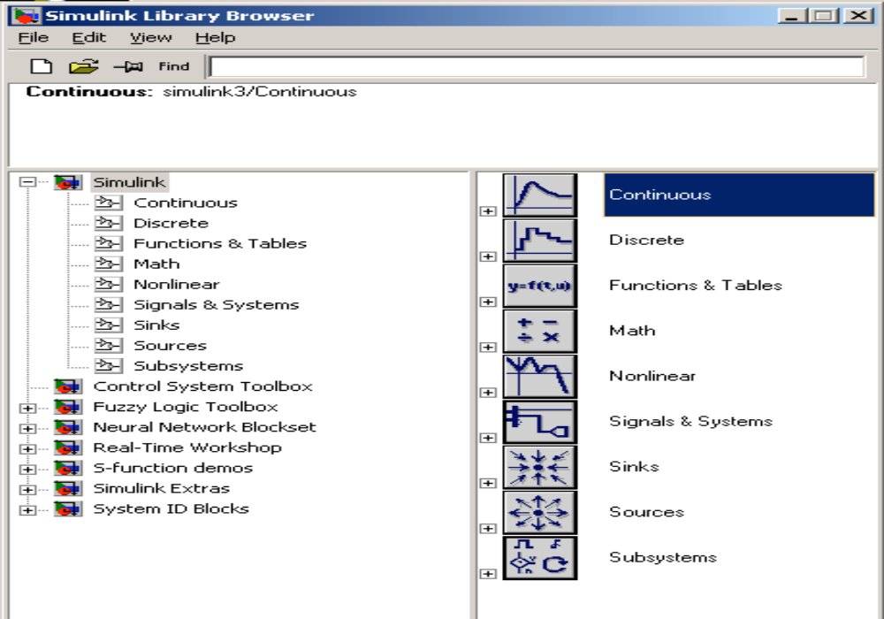
Fig 5.2 Simulink library browser

    - Connecting blocks:

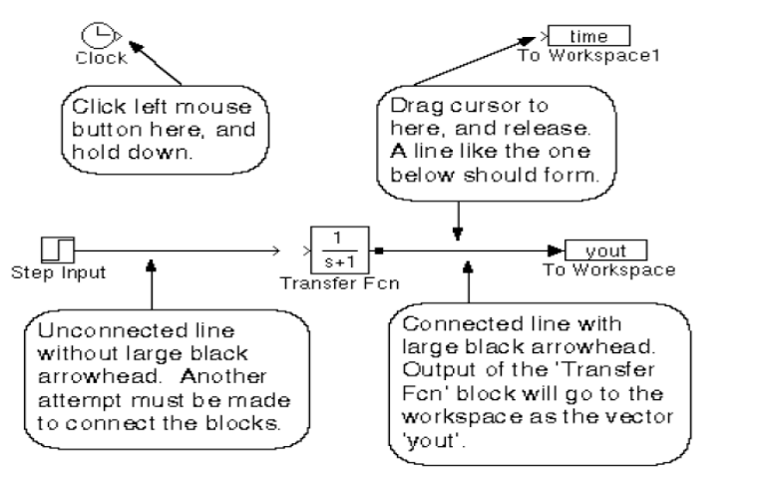
Fig 5.3 Connectung blocks

To connect blocks, left-click and drag the mouse from the output of one block to the input of another block.

5.8.3.1 Sources and sinks:
The sources library contains the sources of data/signals that one would use in a dynamic system simulation. One may want to use a constant input, a sinusoidal wave, a step, a repeating sequence such as a pulse train, a ramp etc. One may want to test disturbance effects, and can use the random signal generator to simulate noise. The clock may be used to create a time index for plotting purposes. The ground could be used to connect to any unused port, to avoid warning messages indicating unconnected ports.

The sinks are blocks where signals are terminated or ultimately used. In most cases, we would want to store the resulting data in a file, or a matrix of variables. The data could be displayed or even stored to a file. The stop block could be used to stop the simulation if the input to that block (the signal being sunk) is non-zero. Fig 4.4 shows the available blocks in the sources and sinks libraries. Unused signals must be terminated, to prevent warnings about unconnected signals.
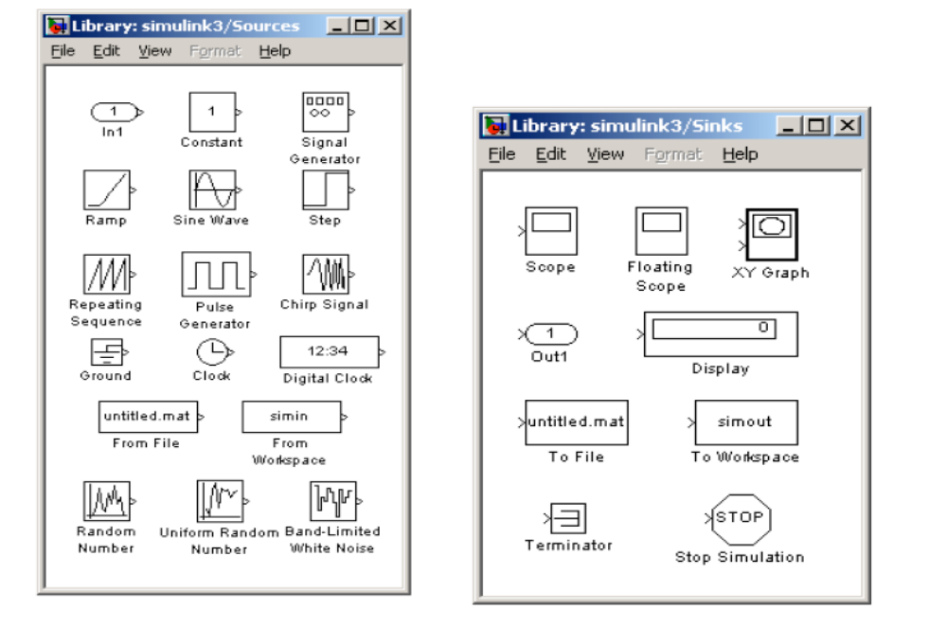
Fig 5.4 Sources and sinks

    - Continuous and discrete systems:
All dynamic systems can be analyzed as continuous or discrete time systems. Simulink allows you to represent these systems using transfer functions, integration blocks, delay blocks etc.
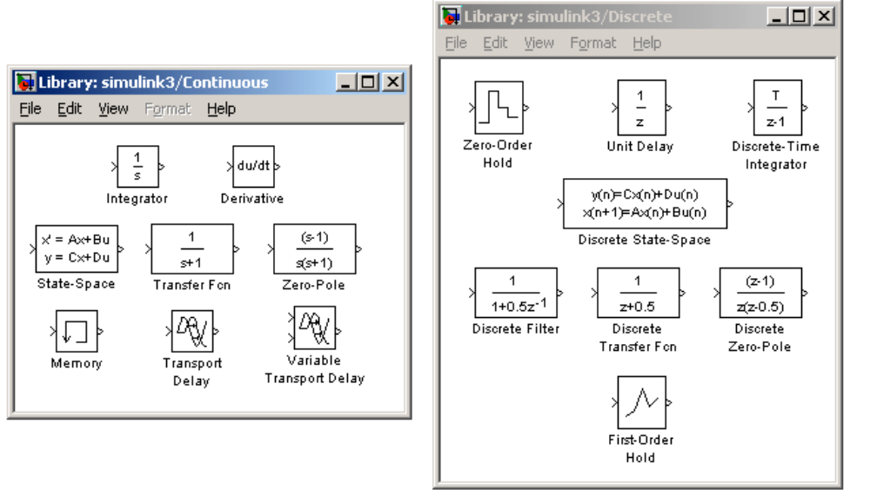
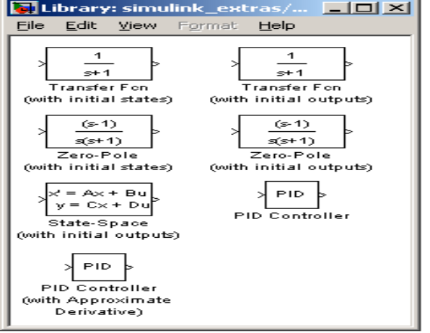

fig 5.5 continous and descrete systems

    - Non-linear operators:
A main advantage of using tools such as Simulink is the ability to simulate non-linear systems and arrive at results without having to solve analytically. It is very difficult to arrive at an analytical solution for a system having non-linearities such as saturation, signup function, limited slew rates etc. In Simulation, since systems are analyzed using iterations, non-linearities are not a hindrance. One such could be a saturation block, to indicate a physical limitation on a parameter, such as a voltage signal to a motor etc. Manual switches are useful when trying simulations with different cases. Switches are the logical equivalent of if-then statements in programming.
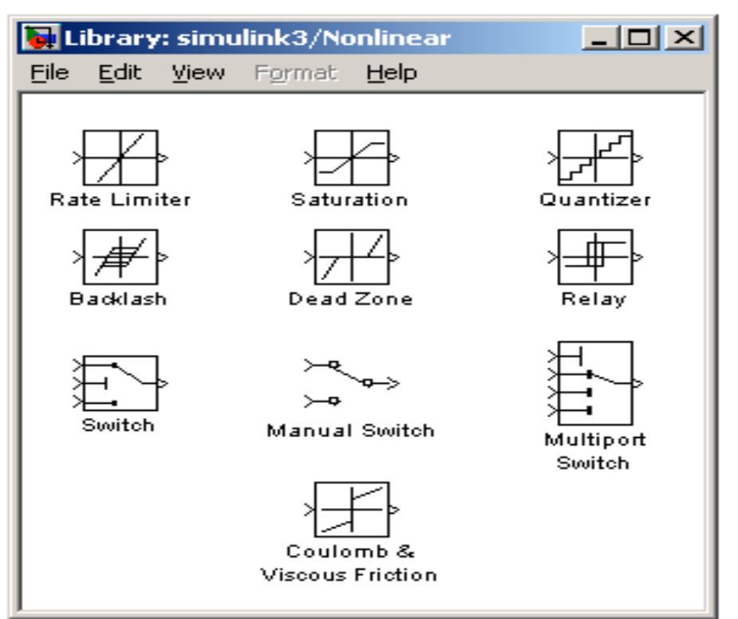
Fig 5.6 simulink blocks

    - Mathematical operations:
Mathematical operators such as products, sum, logical operations such as and, or, etc. can be programmed along with the signal flow. Matrix multiplication becomes easy with the matrix gain block. Trigonometric functions such as sin or tan inverse (at an) are also available. Relational operators such as ‘equal to’, ‘greater than’ etc. can also be used in logic circuits.
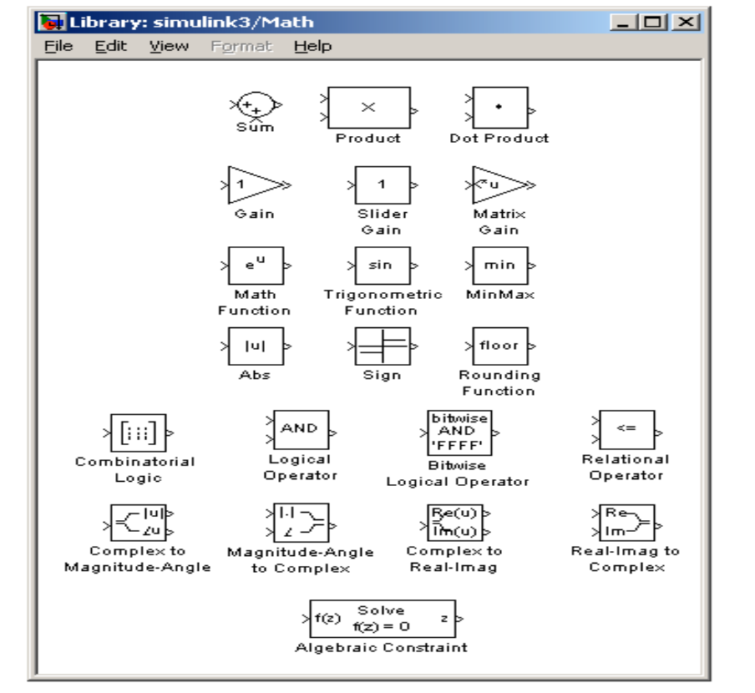
Fig 5.7 Simulink math blocks

    - Signals & data transfer:
In complicated block diagrams, there may arise the need to transfer data from one portion to another portion of the block. They may be in different subsystems. That signal could be dumped into a GOTO block, which is used to send signals from one subsystem to another.
Multiplexing helps us remove clutter due to excessive connectors, and makes matrix (column/row) visualization easier.

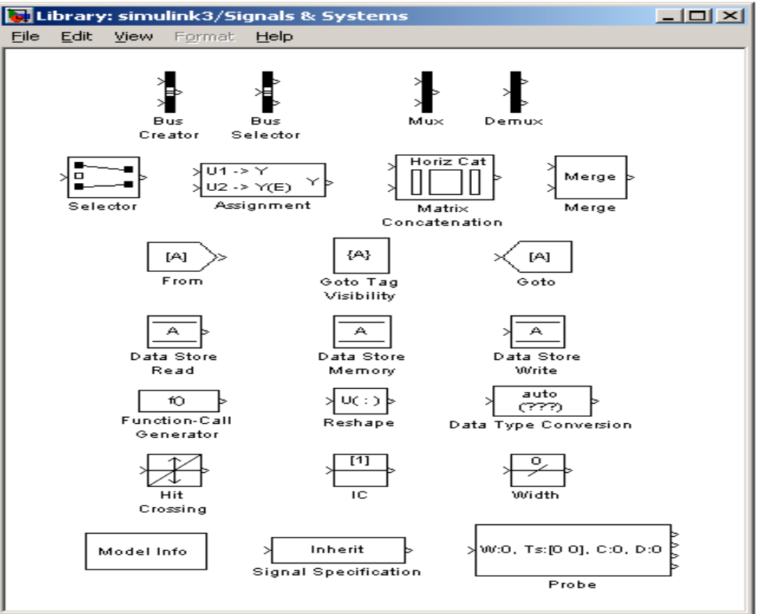
Fig 5.8 signals and systems

    - Making subsystems:
Drag a subsystem from the Simulink Library Browser and place it in the parent block where you would like to hide the code. The type of subsystem depends on the purpose of the block. In general one will use the standard subsystem but other subsystems can be chosen. For instance, the subsystem can be a triggered block, which is enabled only when a trigger signal is received.

Open (double click) the subsystem and create input / output PORTS, which transfer signals into and out of the subsystem. The input and output ports are created by dragging them from the Sources and Sinks directories respectively. When ports are created in the subsystem, they automatically create ports on the external (parent) block. This allows for connecting the appropriate signals from the parent block to the subsystem.

5.8.9Setting simulation parameters:
Running a simulation in the computer always requires a numerical technique to solve a differential equation. The system can be simulated as a continuous system or a discrete system based on the blocks inside. The simulation start and stop time can be specified. In case of variable step size, the smallest and largest step size can be specified. A Fixed step size is recommended and it allows for indexing time to a precise number of points, thus controlling the size of the data vector. Simulation step size must be decided based on the dynamics of the system. A thermal process may warrant a step size of a few seconds, but a DC motor in the system may be quite fast and may require a step size of a few milliseconds.
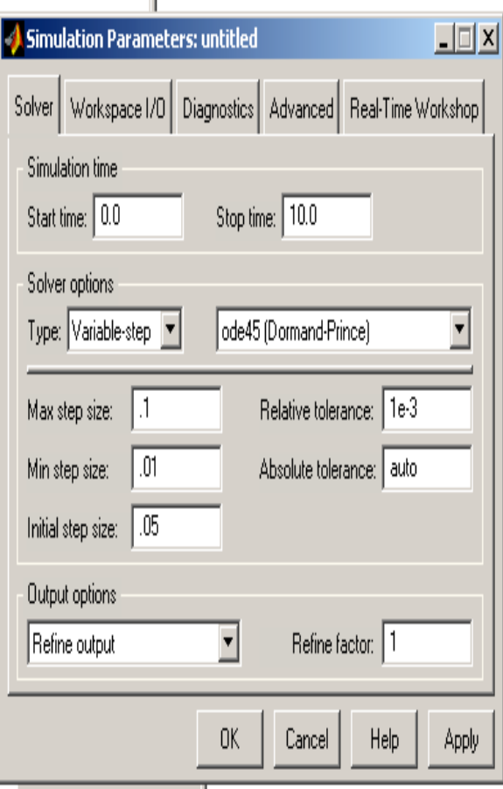

Fig 5.9 setting simulation parameters

  - Sim power system:

5.9.1 Introduction:
Sim Power Systems software and other products of the Physical Modeling product family work together with Simulink software to model electrical, mechanical, and control systems. Sim Power Systems software operates in the Simulink environment. Therefore, before starting this user's guide, make yourself familiar with Simulink documentation. Or, if you perform signal processing and communications tasks (as opposed to control system design tasks), see the Signal Processing Block set documentation.

    - The Role of Simulation in Design:
Electrical power systems are combinations of electrical circuits and electromechanical devices like motors and generators. Engineers working in this discipline are constantly improving the performance of the systems. Requirements for drastically increased efficiency have forced power system designers to use power electronic devices and sophisticated control system concepts that tax traditional analysis tools and techniques. Further complicating the analyst's role is the fact that the system is often so nonlinear that the only way to understand it is through simulation.
Land-based power generation from hydroelectric, steam, or other devices is not the only use of power systems. A common attribute of these systems is their use of power electronics and control systems to achieve their performance objectives.
Sim Power Systems software is a modern design tool that allows scientists and engineers to rapidly and easily build models that simulate power systems. It uses the Simulink environment, allowing you to build a model using simple click and drag procedures. Not only can you draw the circuit topology rapidly, but your analysis of the circuit can include its interactions with mechanical, thermal, control, and other disciplines. This is possible because all the electrical parts of the simulation interact with the extensive Simulink modeling library.
Since Simulink uses the MATLAB computational engine, designers can also use MATLAB toolboxes and Simulink block sets. Sim Power Systems software belongs to the Physical Modeling product family and uses similar block and connection line interface.

Sim power systems Libraries:
Sim Power Systems libraries contain models of typical power equipment such as transformers, lines, machines, and power electronics. These models are proven ones coming from textbooks, and their validity is based on the experience of the Power Systems Testing and Simulation Laboratory of Hydro-Québec, a large North American utility located in Canada, and also on the experience of École de Technology Supérieure and Université Laval. The capabilities of Sim Power Systems software for modeling a typical electrical system are illustrated in demonstration files. And for users who want to refresh their knowledge of power system theory, there are also self-learning case studies.
The Sim Power Systems main library, powerlib, organizes its blocks into libraries according to their behavior. The powerlib library window displays the block library icons and names. Double-click a library icon to open the library and access the blocks. The main powerlib library window also contains the Powergui block that opens a graphical user interface for the steady-state analysis of electrical circuits.

    - Nonlinear Simulink Blocks for Sim power systems Models:

The nonlinear Simulink blocks of the powerlib library are stored in a special block library named powerlib models. These masked Simulink models are used by Sim Power Systems software to build the equivalent Simulink model of your circuit. See Improving Simulation Performance for a description of the powerlib models library.

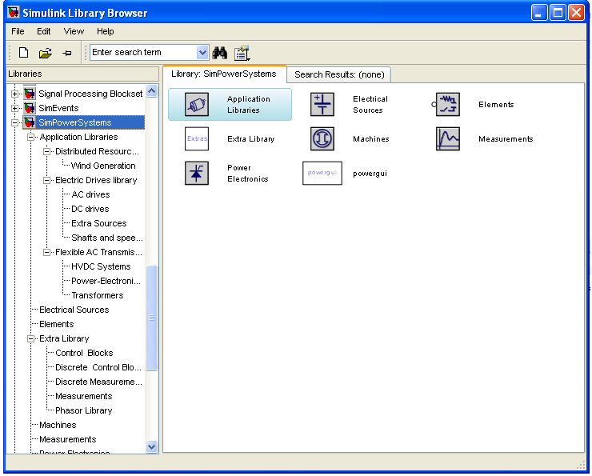
5.10 Diagram of simpower system

5.10 Applications of Matlab:

MATLAB is a data-manipulation software package that allows data to be analyzed and visualized using existing functions and user-designed programs. MATLAB is a numerical computing environment and programming language. MATLAB allows easy matrix manipulation, plotting of functions and data, implementation of algorithms, creation of user interfaces, and interfacing with programs in other languages. Although it specializes in numerical computing, an optional toolbox interfaces with the Maple symbolic engine, allowing it to be part of a full computer algebra system.

Some of the mat lab applications listed are:

Orthogonal frequency division multiplexing

Genetic algorithm data mining

Speech recognition using VQ method

Channel Estimation and Detection in DS-CDMA

Analysis of iterative channel estimation and multi-user detection in multi path DS-CDMA channels

Time-domain signal detection

Time-domain signal detection based on second-order statistics for mimo-OFDM systems

Space–time block coding

Space–time block codes for mimo channels

Blind channel estimation

5.11: Basic circuit designing and analyzing of results:
Click on the file and select new model file and a file will be appeared:
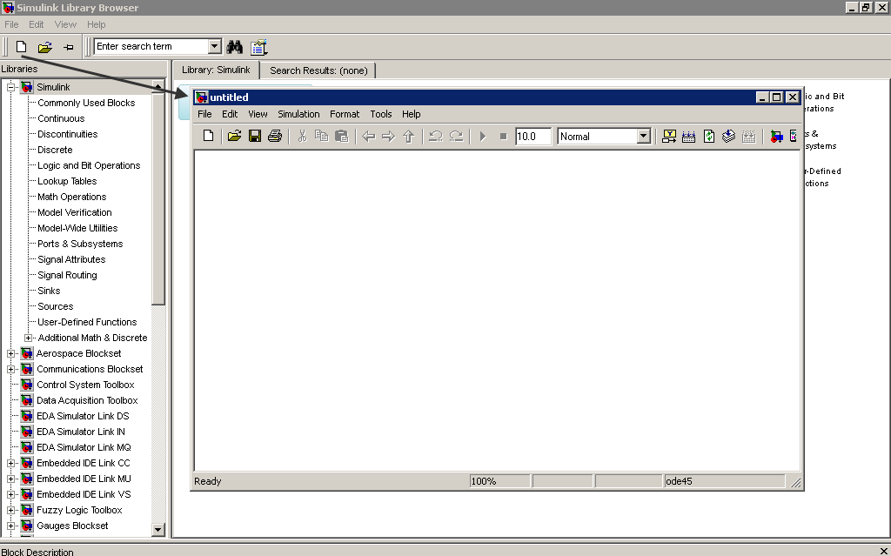
Fig 5.11 Basic circuit designing
Now a block and right click on it, the block will be appearing in the new model file (untitled)
6. MODELLING OF CASE STUDY

6.1 DESCRIPTION AND MODELING OF THE DRIVE SYSTEM
The complete drive system can be categorized into BLDC motor, Inverter, Current Controller, Speed Controller and Quad Determination Block for Four-Quadrant Operation. Each block is modeled separately and integrated together.

6.2 MODELING OF BLDC MOTOR

BLDC motor can be realized mathematically in two ways: abc phase variable model and d-q axis model. In a BLDC motor, the trapezoidal back EMF implies that the mutual inductance between stator and rotor is non-sinusoidal, thus transforming to d-q axis does not provide any particular advantage, and so abc phase variable model is preferred. In the present model, the motor is assumed to be star connected with isolated neutral. Following assumptions are made in modeling the motor.
- The motor is not saturated.
- Stator resistances of all the windings are equal and self and mutual inductances are constant.
- Ideal power semiconductor devices.

The electrical and mechanical system is realized as:
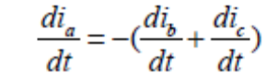……….. (1)
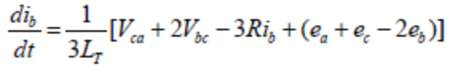…………. (2)
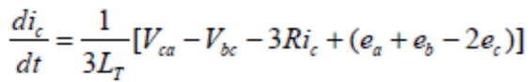…………. (3)
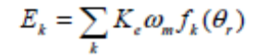…………. (4)
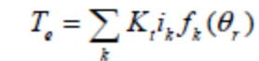………….. (5)
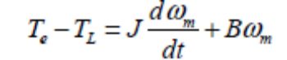……………. (6)
Where, k=a,b,c
i_{k} is the phase current of k_{th} phase
e_{k} is the back-EMF of k_{th} phase
T_{e} is the electricaro magnetic torqe
ω_{m} is the mechanical speed of the motor
J is rotor inertia.
B is damping constant.
R_{s} is the resistance of each phase of the motor
L_{t} is the inductance of the each phase of the motor
K_{t} is torque constant
K _{e} is back-EMF constant
p is the number of poles
f_{k} (θ )_{r} represents the back-EMF as a function of rotor position.

The above equations are sub divided into mechanical and electrical equations representing the BLDC system.

The electrical system equation constitutes (1) to (5). Equation (1) to (3) is obtained by solving the loop equation (7) when an inverter is connected to a star load.
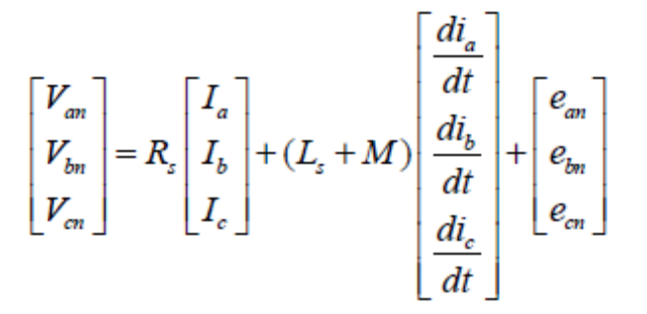……………….. (7)

The back-EMF equations modeled as a normalized function of rotor position is as shown in Table 6.1.

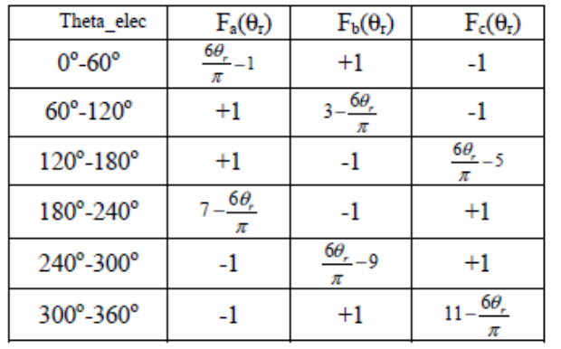
Table 6.1 Back-Emf Modeled As A Function Of Rotor Angle

It may be observed that, the function shown in Table I are 120⁰ phase shifted. The modeling of the motor includes the realization of hall sensors as a function of rotor electrical angle which is listed in Table II.

6.3 Closed-Loop Controller
The BLDC motor is fed by a three phase MOSFET based inverter. The PWM gating signals for firing the power semiconductor devices in the inverter is injected from a hysteresis current controller which is required to maintain the current constant within the 60⁰ interval of one electrical.

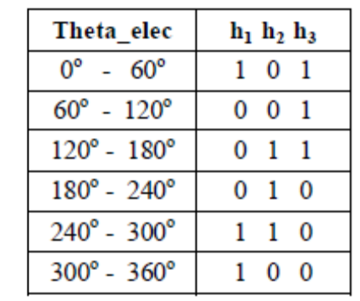
Table 6.2 Hall Sensors Modeled As A Function Of Rotor Angle

It regulates the actual current within the hysteresis band around the reference currents. The reference currents are generated by a reference current generator depending upon the steady state operating mode. The reference currents are of quasi square wave. They are developed in phase with the back-EMF in motoring mode and out of phase in braking mode. The magnitude of the reference current is calculated from the reference torque. The reference torque is obtained by limiting the output of the PI controller. The PI controller processes on the speed error signal (i.e. the difference between the reference speed and actual speed) and outputs to the limiter to produce the reference torque. The actual speed is sensed back to the speed controller and processed on to minimize the error in tracking the reference speed. Thus, it is a closed loop control drive system.

6.4 INVERTER MODELING

The inverter (Fig 6.1) supplies the input voltage for the three phases of the BLDC motor. It comprises of two power semiconductor devices on each phase leg. Appropriate pairs of FET’s (S1 to S6) are driven based on the hall sensors input. Three phases are commutated for every 60⁰ As sensors are the direct feed back of the rotor position, synchronization between stator and rotor flux is achieved. The inverter is implemented using equations (8), (9) and (10).

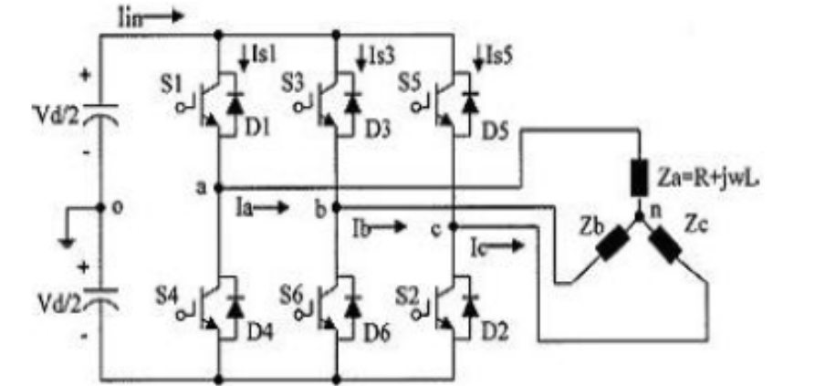
Fig 6.1 Three Phase MOSFET-Based Inverter
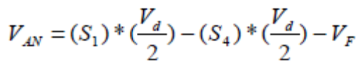…………… (8)
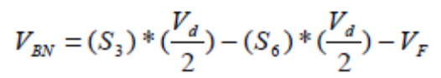……………… (9)
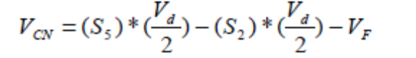………………. (10)

Where V_{AN}, V_{BN} and V_{CN} are line neutral-voltages.
V_{d} is the DC-link voltage.
V_{F} is the forward diode voltage drop.

6.5 Modeling Of Hysteresis Controller
Hysteresis controller limits the phase currents within the Hysteresis band by switching ON/OFF the power devices. The switching pattern is given as:
If i^{err} _{a} >UL , S1 is on and S4 is off.
If i^{err} _{a} < LL , S1 is off and S4 is on.
If i^{err} _{a} >UL , S3 is on and S6 is off.
If i^{err} _{a} < LL , S3 is off and S6 is on
If i^{err} _{a} >UL , S5 is on and S2 is off.
If i^{err} _{a} < LL , S5 is off and S2 is on.
Where 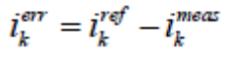 and UL, LL are the upper and lower limits of hysteresis band. Thus, by regulating the current desired quasi-square waveforms can be obtained

6.6 Modeling Of Reference Current Generator
The desired reference currents are injected into the hysteresis controller. The magnitude of the reference current is determined from the reference torque and back-emf constant. The incoming or outgoing direction of the current is determined from hall sensors output and the operating mode. The reference currents for four steady state operations are modeled as shown in Table 5.3 (Forward motoring and reverse braking) and Table 5.4 (Reverse motoring and forward braking:

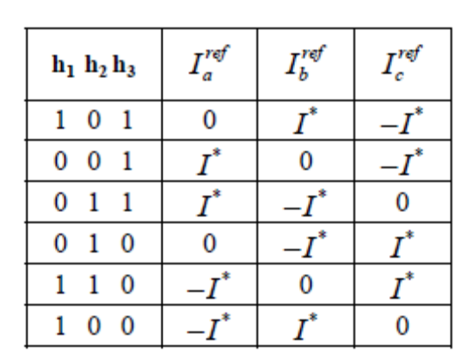
Table 6.3 Reference Currents For Forward Motoring And Reverse Braking

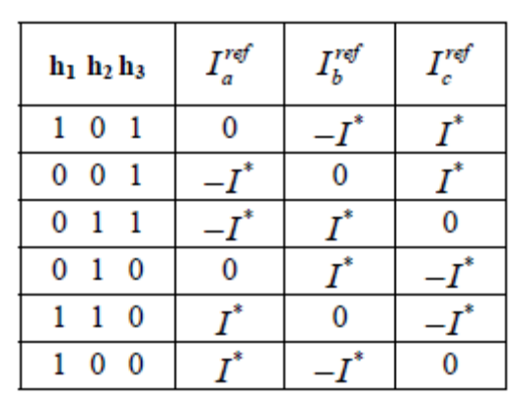
Table 6.4 Reference Currents For Reverse Motoring And Forward Braking

6.7 Modeling of Speed Controller
Conventional PI controller is used as a speed controller for recovering the actual motor speed to the reference. The reference and the measured speed are the input signals to the PI controller. The KP and KI values of the controller are determined by trial and error method for each set speed. The controller output is limited to give the reference torque.

6.8 Modeling of Quadrant Determination subsystem
The set speed and the actual speed determine the operating mode of the motor. Based on the quadrant in which the motor operates, the required reference currents are generated.

7. BLOCK DIAGARAM OF THE SYSTEM

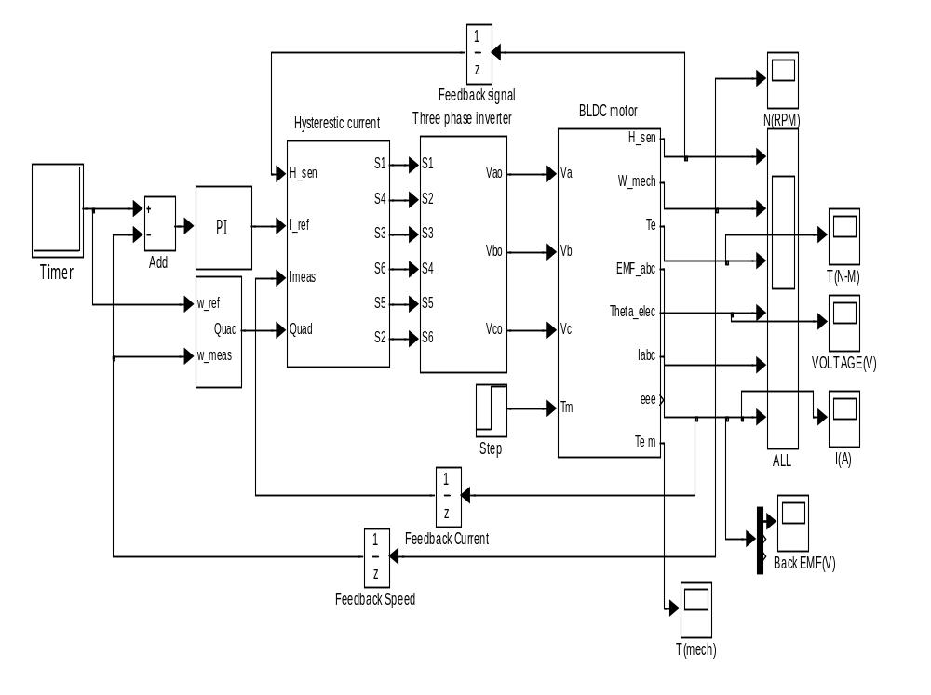
Fig 7.1 The simulation model of BLDC motor

8. SIMULATION RESULTS

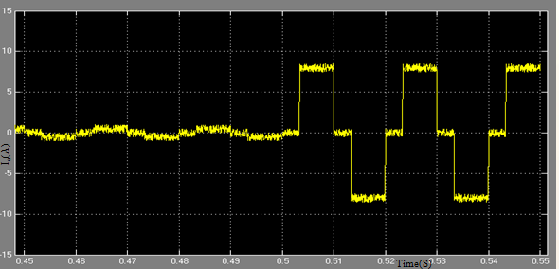
Fig 8.1 Phase A Current under Load Condition

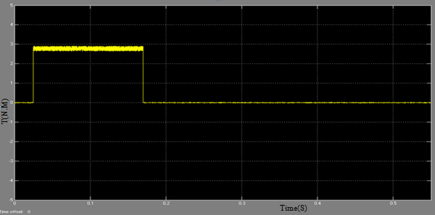
Fig 8.2 The torque response waveform
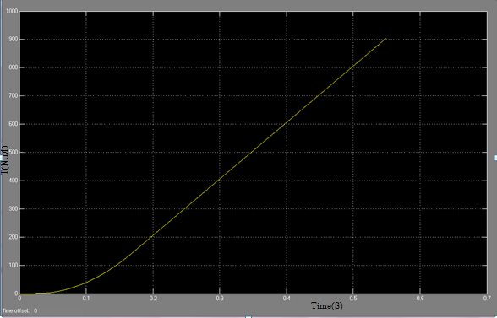
Fig 8.3 .Mechanical Torque Wave form
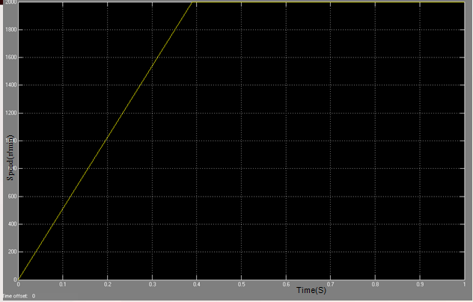
Fig 8.4 Speed -Time Characteristics
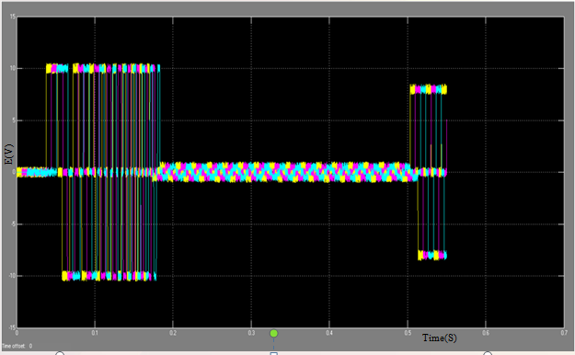
Fig.8.5 Three phase back-EMF waveform

9. CONCLUSIONS

Motor is established in Matlab/Simulink on the basis of the motor performance of the requirements in the column–type EPS system and the electromagnetic equations of BLDC motor. The fruitful simulation results show that the proposed control strategy of the BLDC motor is valid. Based on the study above, according to the specific characteristics of EPS, changing the part of the functional modules or control strategies is convenient, so a more precise current control strategy of BLDC motor for EPS will be further researched.

REFERENCES

[1] P.Pillay and R.Krishnan, “Modeling, simulation and analysis of permanent-magnet motor drives, part-II: the brushless DC motor drives,” IEEE Trans. on Industry Applications, vol. 25, pp.274-279, March/April 1989.

[2] S.K.Safi, P.P.Acarnley and A. G. Jack. “Analysis and simulation of the high-speed torque performance of brushless DC motor drives,” Proc. Of IEE, vol 142, no.3, p.p.191-200, May 1995.

[3] Krishnan R motor “Drives Modeling, Analysis and Control”, Prentice Hall of India, First Edn, 2002, Chapter 9, pp 513-615..

[4] Byoung-Kuk Lee and Mehrdad Ehsani, “Advanced Simulation Model for Brushless DC Motor Drives”, Electric Power Component And Systems, 31:841-868, 2003.

[5] Dr.B.Singh, Prof B P Singh and C. L. Putta Swamy,“Modelling of Variable Structure Controlled Permanent Magnet Brushless dc Motor”, IE(I)_Journal-EL, Vol 75, Febraury 1995.

[6] Gopal K Dubey “Fundamentals of Electrical Drives”, Narosa Publishing House, New Delhi, Second Edn, 2001, Chapter 7, pp271-277.

[7] Bimal K Bose, “Modern Power Electronics and AC Drives”, Pearson Education Publications, New Delhi, 2002, Chapter 9, pp483 - 495.

[8] Tae-Hyung Kim et al, IEEE publication no. 0-7803-7768-0/03.

